# Project: Analyzing a Market Test

## **Step 1: Plan Your Analysis**

1. **What is the performance metric you’ll use to evaluate the results of your test?**

The total gross margin is the performance metric that I will use. It will be helpful for us to see if it is worth to introduce new menu for the store.

1. **What is the test period?**

Total 12 weeks of time from 04/29/2016 to 07/21/2016.

1. **At what level (day, week, month, etc.) should the data be aggregated?**

Since the transaction data we had is from 01/21/2015 to 08/18/2016, we had around 1 year of data. Due to data is daily invoice, we can aggregate in weekly level.

## **Step 2: Clean Up Your Data**

*In this step, you should prepare the data for steps 3 and 4. You should aggregate the transaction data to the appropriate level and filter on the appropriate data ranges. You can assume that there is no missing, incomplete, duplicate, or dirty data. You’re ready to move on to the next step when you have weekly transaction data for all stores.*

## **Step 3: Match Treatment and Control Units**

*In this step, you should create the trend and seasonality variables, and use them along with you other control variable(s) to match two control units to each treatment unit. Note: Calculate the number of transactions per store per week to calculate trend and seasonality.*

1. **What control variables should be considered? Note: Only consider variables in the RoundRoastersStore file.**

*The two control variables in the file which is numerical are sq-ft and AvgMonthSales.*

*While after perform correlation measurement, we should ignore sq_ft.*

1. **What is the correlation between each potential control variable and your performance metric?**

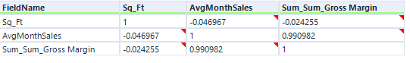

*Performance metric is highly related to AvgMonthsales, less related to sq_ft. Thus, we should skip control variable sq-ft.*

1. **What control variables will you use to match treatment and control stores?**

As explained above, AvgMonthSales, *trend and Seasonality will be used, when matching treatment and control stores. The trend and seasonality are calculated from the traffic (unique number of invoice per store per week).*

1. **Please fill out the table below with your treatment and control stores pairs:**

|  |  |  |
| --- | --- | --- |
| Treatment Store | Control Store 1 | Control Store 2 |
| 1664 | 7162 | 8112 |
| 1675 | 1580 | 1807 |
| 1696 | 1964 | 7334 |
| 1700 | 1630 | 2014 |
| 1712 | 7434 | 8162 |
| 2288 | 2568 | 9081 |
| 2293 | 9524 | 12219 |
| 2301 | 3102 | 9238 |
| 2322 | 2409 | 3235 |
| 2341 | 2383 | 12536 |

## **Step 4: Analysis and Writeup**

1. **What is your recommendation - Should the company roll out the updated menu to all stores?**

*Yes, the company should update the menu to all the stores, due to lift is 40.7% with significance level of 100%. As seen from below lift confident.*

1. **What is the lift from the new menu for West and Central regions (include statistical significance)?**

*For west region, lift is 37.9%*

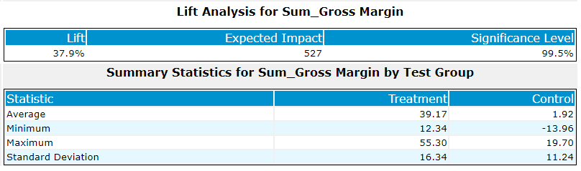

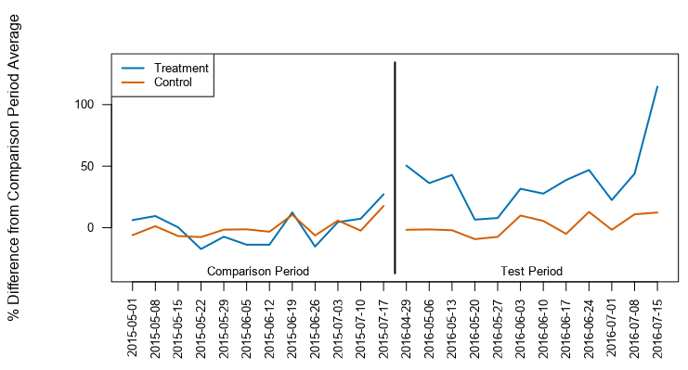

*For central region, life is 43.5%*

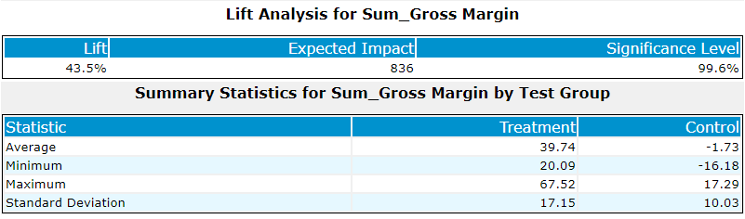

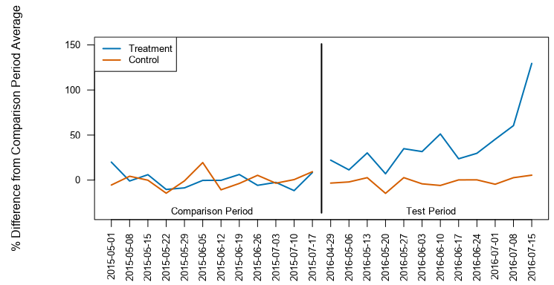

1. **What is the lift from the new menu overall?**

*Lift for overall is 40.7%.*

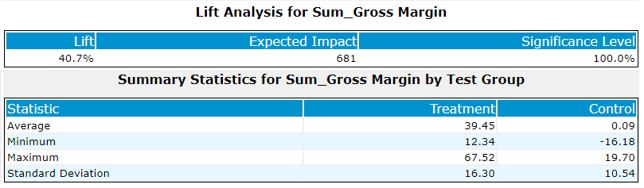

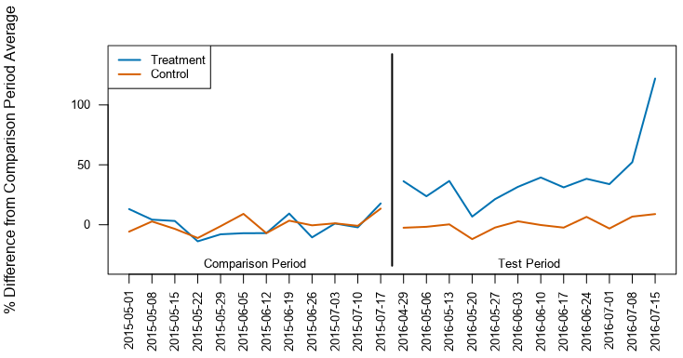

Workflow attach as follows:

